**Design of Digital Systems Laboratory**

**Assignment Lab 2**

Brian Ryner

By submitting this report, you attest that you neither have given nor have received any assistance (including writing, collecting data, plotting figures, tables, or graphs, or using previous student assignments as a reference), and you further acknowledge that giving or receiving such assistance will result in a failing grade for this course.

|  |  |
| --- | --- |
| Your Signature: | Brian Ryner |

**Synopsis**

In Lab 2 we create several registers which we then program values to using the address bits to select registers. After which we then disable write enable and read the values back from each of the addresses we stored. 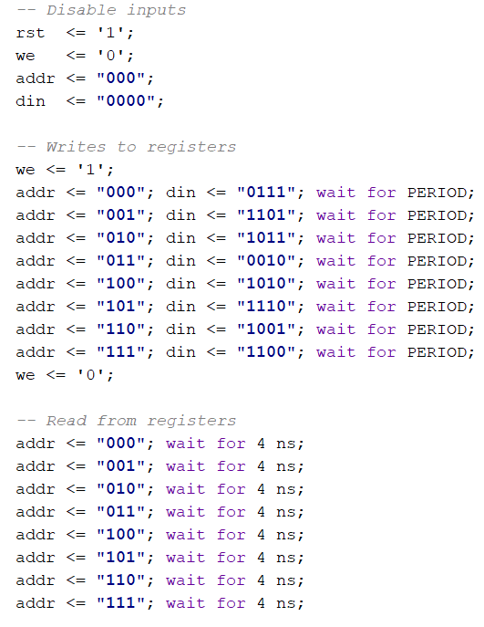 This can be seen directly in the testbench for our Register File.

**Waveform**

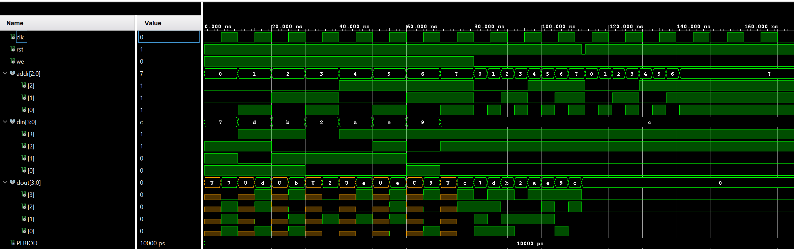

**Implementation**

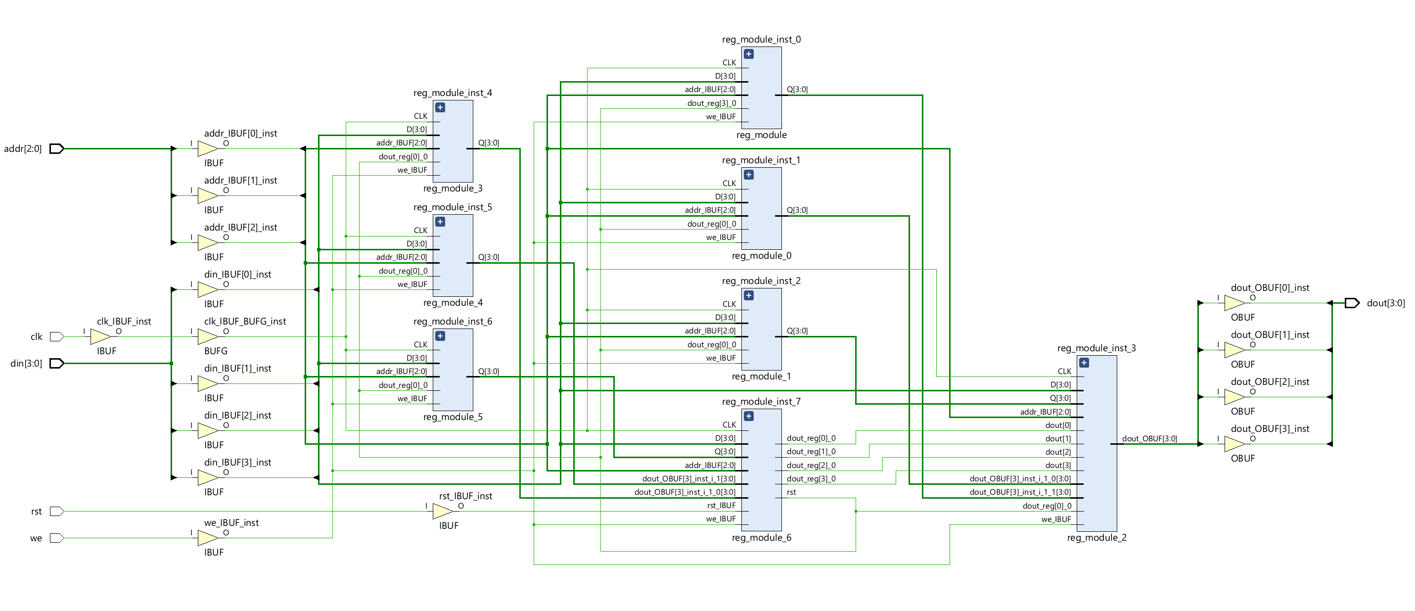

**Video Demonstration**

https://youtu.be/ipVW34nSkhg

**Filenames**

design.vhd = design

sim.vhd= simulation

blackboard_revD.xdc = **blackboard** constraint file

Nexys-4-DDR-Master.xdc = **Nexys** constraint file

lab2_report.docx

(running as a remote student on a different xilinx board so a different constraint file is necessary for my implementations. I will be providing that as well as the compatible Nexys constraint file if verification is necessary on your end.)

**Findings and Observations**

As Shown in my accompanying video I had issues calling back some of the programmed values correctly.. thus the abrupt ending. After a couple days of troubleshooting, I’ve concluded that there is a partial board failure on my end where certain pins are shorted and it can be seen in these attached pictures. Where the same Address is selected (100), we see different 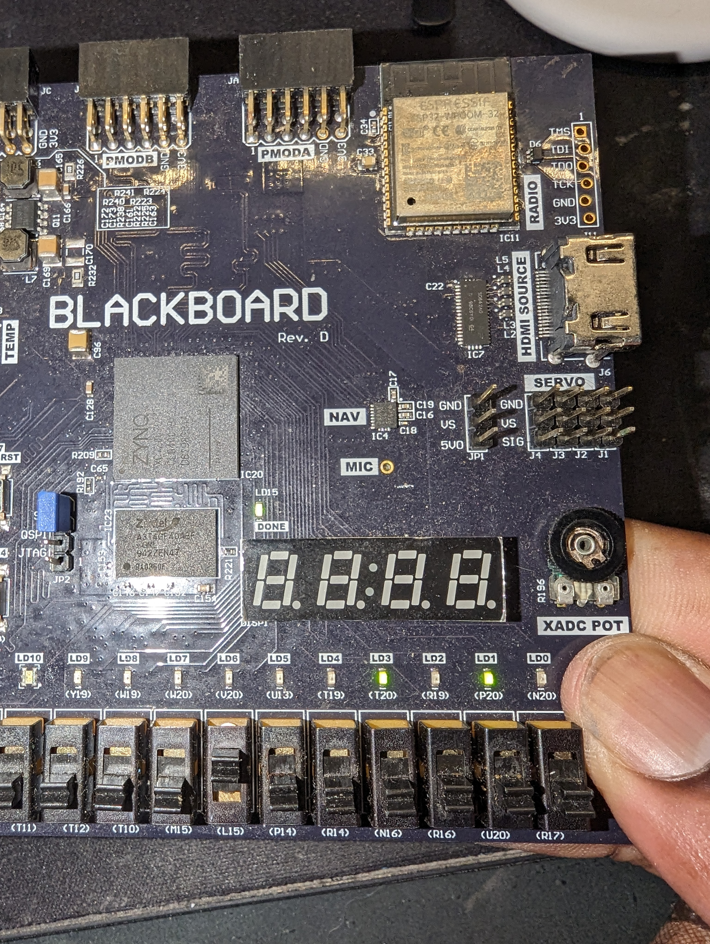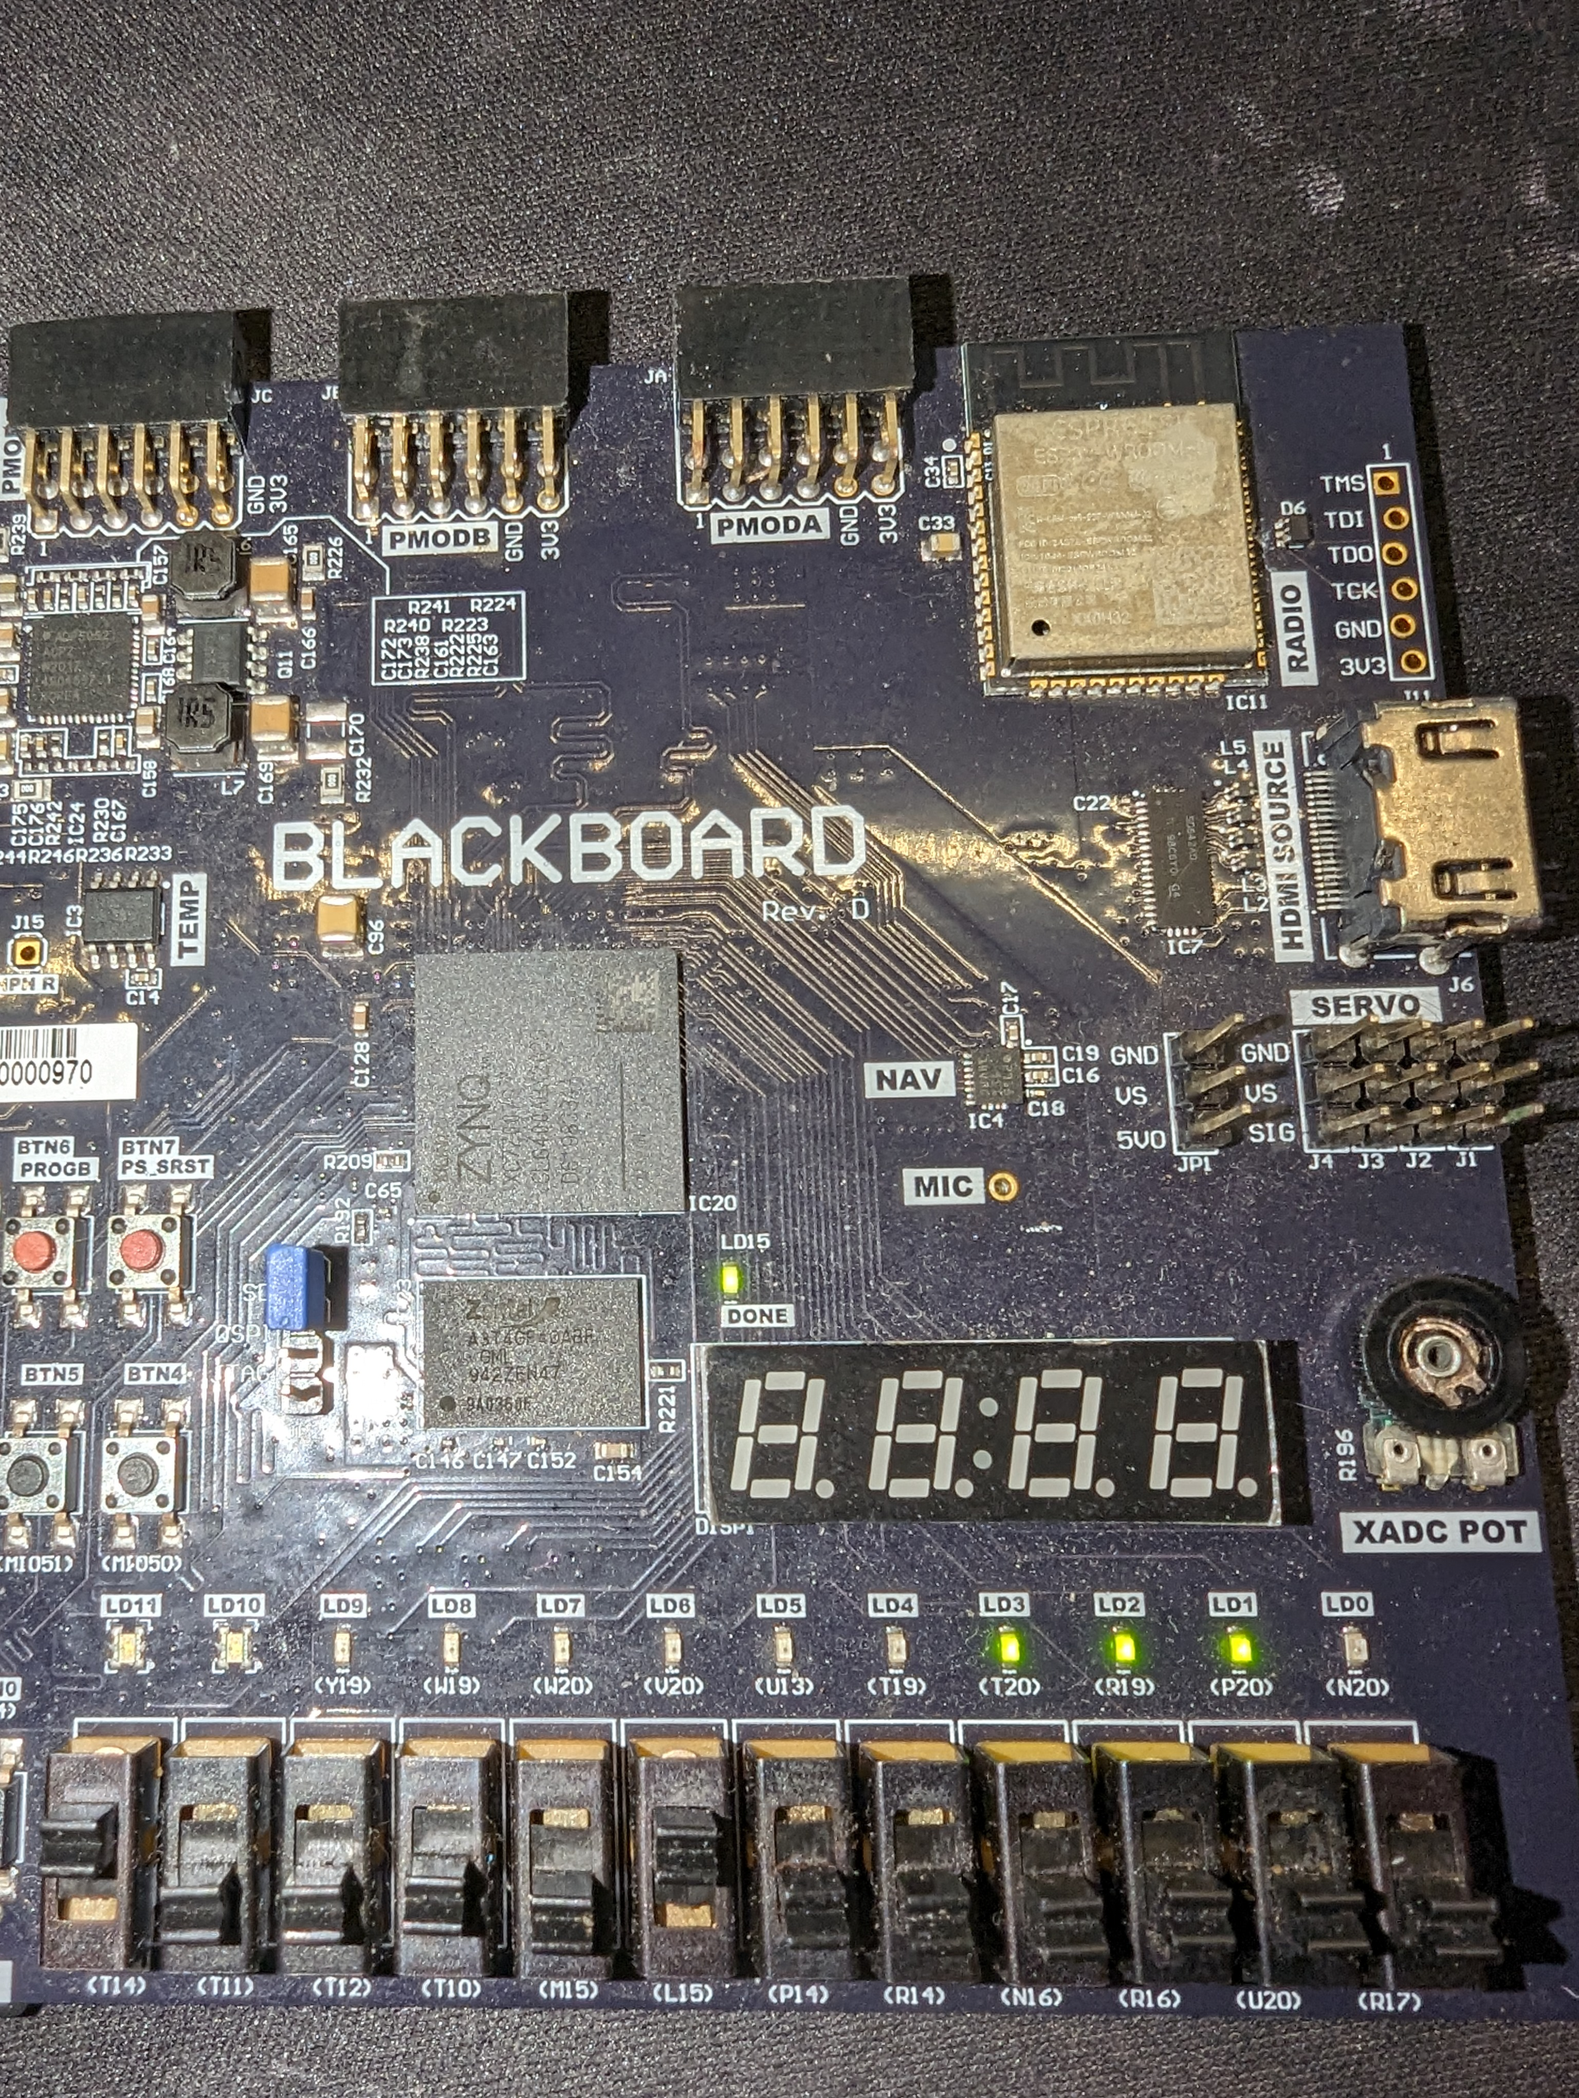Dout LED values, 1010 and 1110. The when my fingers made contact with certain parts of the board on the back, it seemed to stop shorts that were occuring causing the wrong output. This is furter backed by my Simulation file outputting the correct results when each of the addr busses are recalled